import pandas as pd

df=pd.read_csv()

df.head()

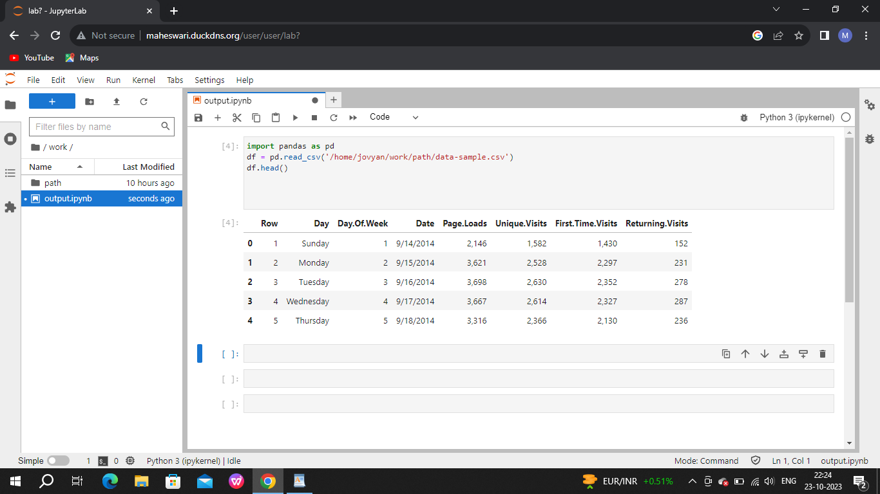

df.info()

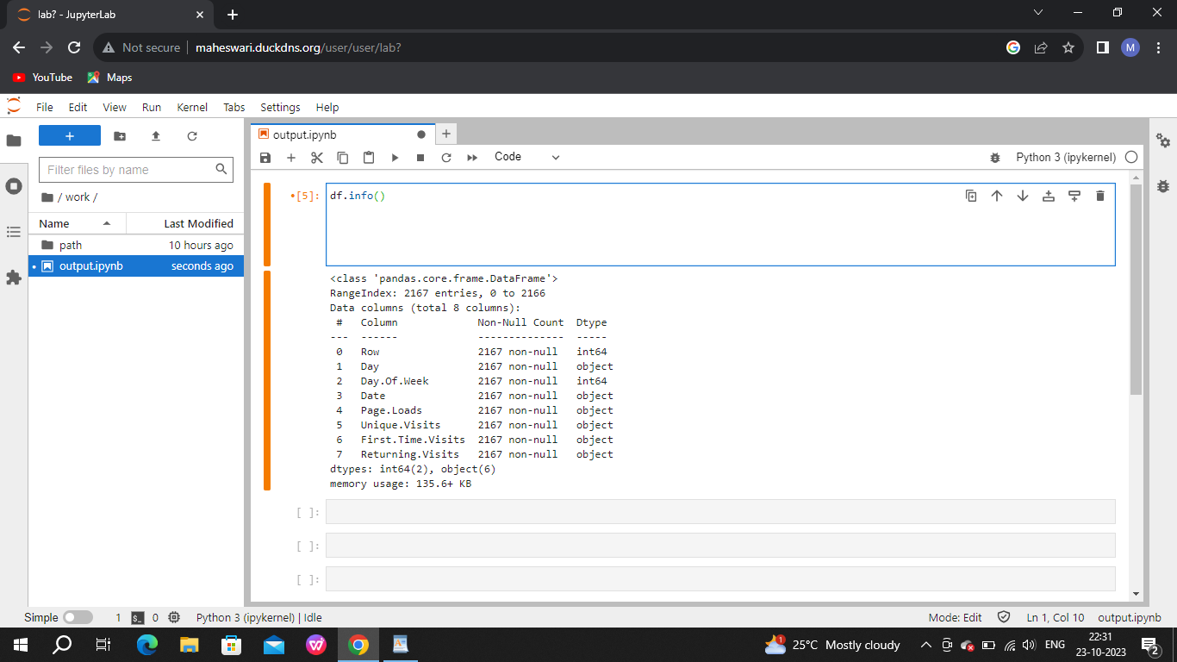

import pandas as pd

data=pd.read_csv("/home/jovyan/work/path/data-sample.csv")

print(data.head())

